**Focus keyword**: **Foresight Mental Health**

**Meta Title:**– **Foresight Mental Health**|vigoursoul

**Meta Description:** **Foresight Mental Health** is a mental health organization .We offer a range of mental health services, including psychotherapy, medication management, and case management.

**Feature Image:**

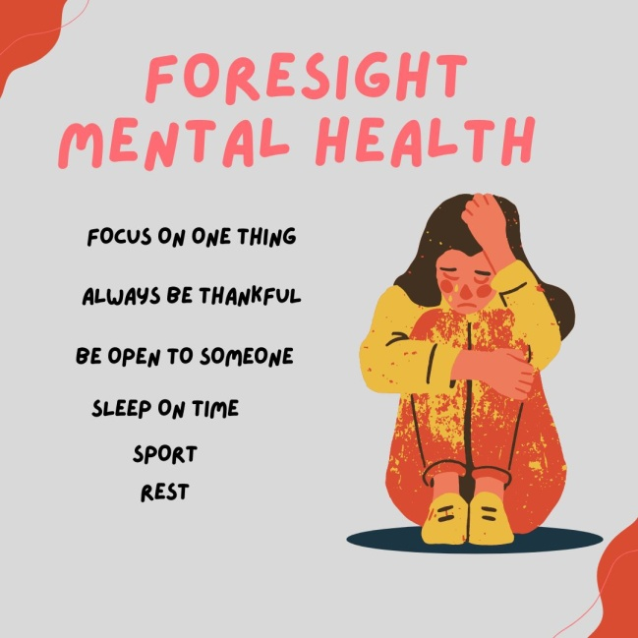

**Foresight Mental Health**

**Foresight Mental Health** introduction is a concept that seeks to raise public awareness about mental health, reduce stigma, and promote understanding of mental health issues. It involves educating individuals about mental health, providing information about available resources and support, and advocating for better mental health policies and services.

It may include activities such as public talks, media campaigns, and social media initiatives. Mental health introduction is a cornerstone of mental health promotion and prevention, and is an important step toward improving access to mental health care and creating a more supportive environment for people living with mental illness.

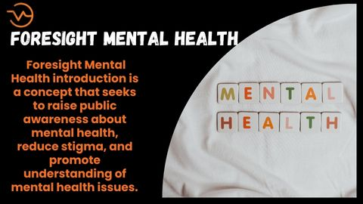

**Matt Milford and Doug Hapeman Idea:**

With a goal to revolutionize mental health care, Matt Milford and Doug Hapeman left UC Berkeley. With the aid of cutting-edge technology, their business, Foresight Mental Health, provides patients with highly customized, data-supported treatment regimens for mental health issues.

Berkeley-based Foresight offers patients a wide range of treatments and services to enhance lifestyle and mental health. The business, which aims to change the sector, is made up of therapists, neuropsychologists, software engineers, bioengineers, dietitians, and data scientists.

Matt and Doug were dissatisfied with the way American mental healthcare is run. They explained that in the Bay Area, the percentage is considerably higher, with 55% of psychiatrists refusing to accept health insurance. Less than 15% of healthcare providers do not accept insurance, in comparison, in the sector.

With the use of a unique patient profile, Foresight examines crucial data such as a person's genetics, extensive symptoms, and estimated brain-chemical balance. To generate a unique patient portfolio, Foresight combines this information with their patients' family history, lifestyle, and mental health history.

Through SCET's summer abroad programme, Matt gained a close-up view of innovation and entrepreneurship at the European Innovation Academy in Nice, France in the summer of 2016. Matt received a head start in technology and entrepreneurship at EIA. He co-founded Foresight Mental Health with his buddy and co-founder Doug because of his enthusiasm for mental healthcare and his interests in entrepreneurship and innovation.

Foresight works with people of all ages, but its main goal is to support university-age students. Currently, they provide assistance to hundreds of UC Berkeley students at nearby locations.

**Foresight Mental Health**

**Foresight mental health** refers to the proactive assessment, prevention, and management of mental health issues. It seeks to identify potential mental health hazards and to take steps to mitigate the impact of these hazards before they manifest into full-blown mental health issues. It involves the use of evidence-based strategies such as early detection, comprehensive assessment, comprehensive treatment plans, and risk-reduction strategies.

It also incorporates preventive measures such as promoting positive coping strategies, teaching stress management skills, and providing psychoeducation. **Foresight Mental Health** emphasizes the importance of creating a supportive environment for those who may be at risk for developing mental health issues and for those who are currently living with mental illness.

Public speeches, media campaigns, and social media campaigns are a few examples of possible activities. A crucial component of mental health promotion and prevention, mental health introduction is a crucial step in enhancing access to mental health care and building a more accepting community for those who are dealing with mental illness.

**Foresight Mental Health Careers and Services:**

Talented people are always needed to expand team at Foresight Mental Health. Clinicians, case managers, programme coordinators, and support personnel are among the many positions that are now open. We are dedicated to establishing a multicultural, welcoming workplace where everyone is recognized and cherished. We provide accommodating schedules, competitive compensation, and a positive workplace culture. Visit our website for additional details about the open roles if you're interested in joining our team.

**Foresight Mental Health Headquarters:**

Sacramento, California serves as the headquarters of Foresight Mental Health. Additionally, we have locations in Berkeley, Bakersfield, and Fresno. Our staff is dedicated to giving people and families in the greater Sacramento area top-notch mental health care. We work to foster an atmosphere of compassion, encouragement, and optimism as well as to give people the tools they need to actively participate in their own mental health care.



**Foresight Mental Health Berkeley**

Perspective Mental Health Based in Berkeley, California, Berkeley is a mental health organization. We provide a variety of mental health treatments, such as case management, medication management, and counseling. Additionally, we offer community outreach, advocacy, and psychoeducation.

Our goal is to offer comprehensive mental health services to local residents and families while also fostering an atmosphere of compassion, understanding, and optimism. Our objectives are to lessen the stigma attached to mental illness and to enable people to actively participate in their own mental health care.

**Foresight Mental Health Atlanta**

Unfortunately, Atlanta, Georgia, does not presently host a location for Foresight Mental Health. We are a Sacramento, California-based mental health company that provides a variety of mental health services to the entire state. Although we are not actively working to expand our services to Atlanta right now, we would be pleased to put you in touch with some other regional mental health service providers.

**Foresight Mental Health Crunchbase**

There isn't a Crunchbase page for Foresight Mental Health at the moment. On the other hand, we are dedicated to offering high-quality mental health care and are actively involved in the community of greater Sacramento. We actively participate in both the American Psychological Association and the National Alliance on Mental Illness (NAMI) (APA). We work hard to give our patients the greatest care and to be a dependable resource for advice and assistance regarding mental health.

**Foresight Mental Health Oakland**

There isn't a Foresight Mental Health office in Oakland, California right now. We are a Sacramento, California-based mental health company that provides a variety of mental health services to the entire state. Although we are not actively seeking to expand our services to Oakland at the moment, we would be pleased to put you in touch with some other nearby mental health service providers.

**Foresight Mental Health San Francisco**

**Foresight Mental Health** does not currently have an office in San Francisco, California. We are a mental health organization based in Sacramento, California and offer a range of mental health services throughout the state. We are currently not actively looking to expand our services to San Francisco, but we would be happy to connect you with other local mental health providers in the area.

**Foresight Mental Health Customer Services:**

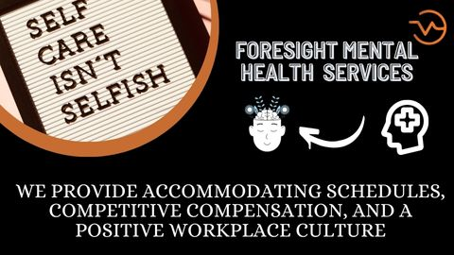

**Foresight Mental Health** offers a variety of customer services that are designed to meet the unique needs of our clients. We offer a 24-hour crisis hotline, where individuals can speak with a mental health professional and receive support. We also have an online chat service, which allows individuals to reach out to us anonymously and receive help quickly. Additionally, we offer our clients access to a variety of online resources, including educational videos, webinars, and self-assessment tools. To learn more about our customer services, please visit our website.

**Foresight Mental Health Address**

Foresight Mental Health 3090 Broadway,

Phone: (916) 454-9191

Fax: (916) 454-9192

Email: [info@foresightmentalhealth.com](mailto:info@foresightmentalhealth.com)

**Foresight Mental Health Glassdoor**

**Foresight Mental Health** does not currently have a Glassdoor page. However, our website and social media accounts regularly feature reviews from former and current clients. We also have a blog that covers a range of mental health topics, including advice for managing stress, understanding depression, and building healthy relationships.

Additionally, we are active members of the National Alliance on Mental Illness (NAMI) and the American Psychological Association (APA). We strive to provide the best care possible to our clients and to be a trusted source of mental health information and support.

**Foresight Mental Health Layoffs**

**Foresight Mental Health** does not currently have any planned layoffs. We are committed to providing quality mental health care and we strive to ensure our staff are supported and valued. We understand the importance of providing stability and security, and we take measures to protect our team from any potential layoffs.

**Foresight Mental Health-FAQS**

**What services does Foresight Mental Health offer?**

**Foresight Mental Health** offers a range of mental health services, including psychotherapy, medication management, case management, psychoeducation, advocacy, and community outreach. Our goal is to reduce the stigma associated with mental health, and to empower individuals to take an active role in their mental health care.

**Are there any Foresight Mental Health offices in Georgia?**

Unfortunately, **Foresight Mental Health** does not currently have an office in Georgia. We are a mental health organization based in Sacramento, California and offer a range of mental health services throughout the state. We would be happy to connect you with other local mental health providers in the area.

**Is there a Foresight Mental Health Glassdoor page?**

**Foresight Mental Health** does not currently have a Glassdoor page. However, our website and social media accounts regularly feature reviews from former and current clients. We also have a blog that covers a range of mental health topics, including advice for managing stress, understanding depression, and building healthy relationships.

**What is Foresight Mental Health’s mission?**

Foresight Mental Health’s mission is to provide comprehensive mental health services to individuals and families in the greater Sacramento area, and to create an environment of understanding, support, and hope. Our goal is to reduce the stigma associated with mental health, and to empower individuals to take an active role in their mental health care.

**Does Foresight Mental Health offer any customer services?**

Yes, **Foresight Mental Health** offers a variety of customer services that are designed to meet the unique needs of our clients.. We also have an online chat service, which allows individuals to reach out to us anonymously and receive help quickly.

**Does Foresight Mental Health have a Crunchbase page?**

**Foresight Mental Health** does not currently have a Crunchbase page. However, we are committed to providing quality mental health care and are actively involved in the greater Sacramento community. We are active members of the National Alliance on Mental Illness (NAMI) and the American Psychological Association (APA).

**Does Foresight Mental Health offer any positions?**

Yes, **Foresight Mental Health** is always looking for talented individuals to join our team. We have a variety of open positions, including clinicians, case managers, program coordinators, and administrative staff. We are committed to creating a diverse, inclusive workplace where all individuals are respected and valued.

**What is the goal of Foresight Mental Health?**

The goal of **Foresight Mental Health** is to provide comprehensive mental health services to individuals and families in the greater Sacramento area, and to create an environment of understanding, support, and hope. Our goal is to reduce the stigma associated with mental health and to empower individuals to take an active role in their mental health care.

**Conclusion**

**Foresight Mental Health** is a mental health organization based in Sacramento, California. We offer a range of mental health services, including psychotherapy, medication management, and case management. We also provide psychoeducation, advocacy, and community outreach.

Our mission is to provide comprehensive mental health services to individuals and families in the greater Sacramento area, and to create an environment of understanding, support, and hope. Our goal is to reduce the stigma associated with mental health and to empower individuals to take an active role in their mental health care. If you are interested in learning more about Foresight Mental Health, please visit our website or contact us directly.